RedBook Casting [www.redbookcasting.co.uk](http://www.redbookcasting.co.uk)

**Mark Duncan Prescott**

**(Stage name : Mark Leatham)**

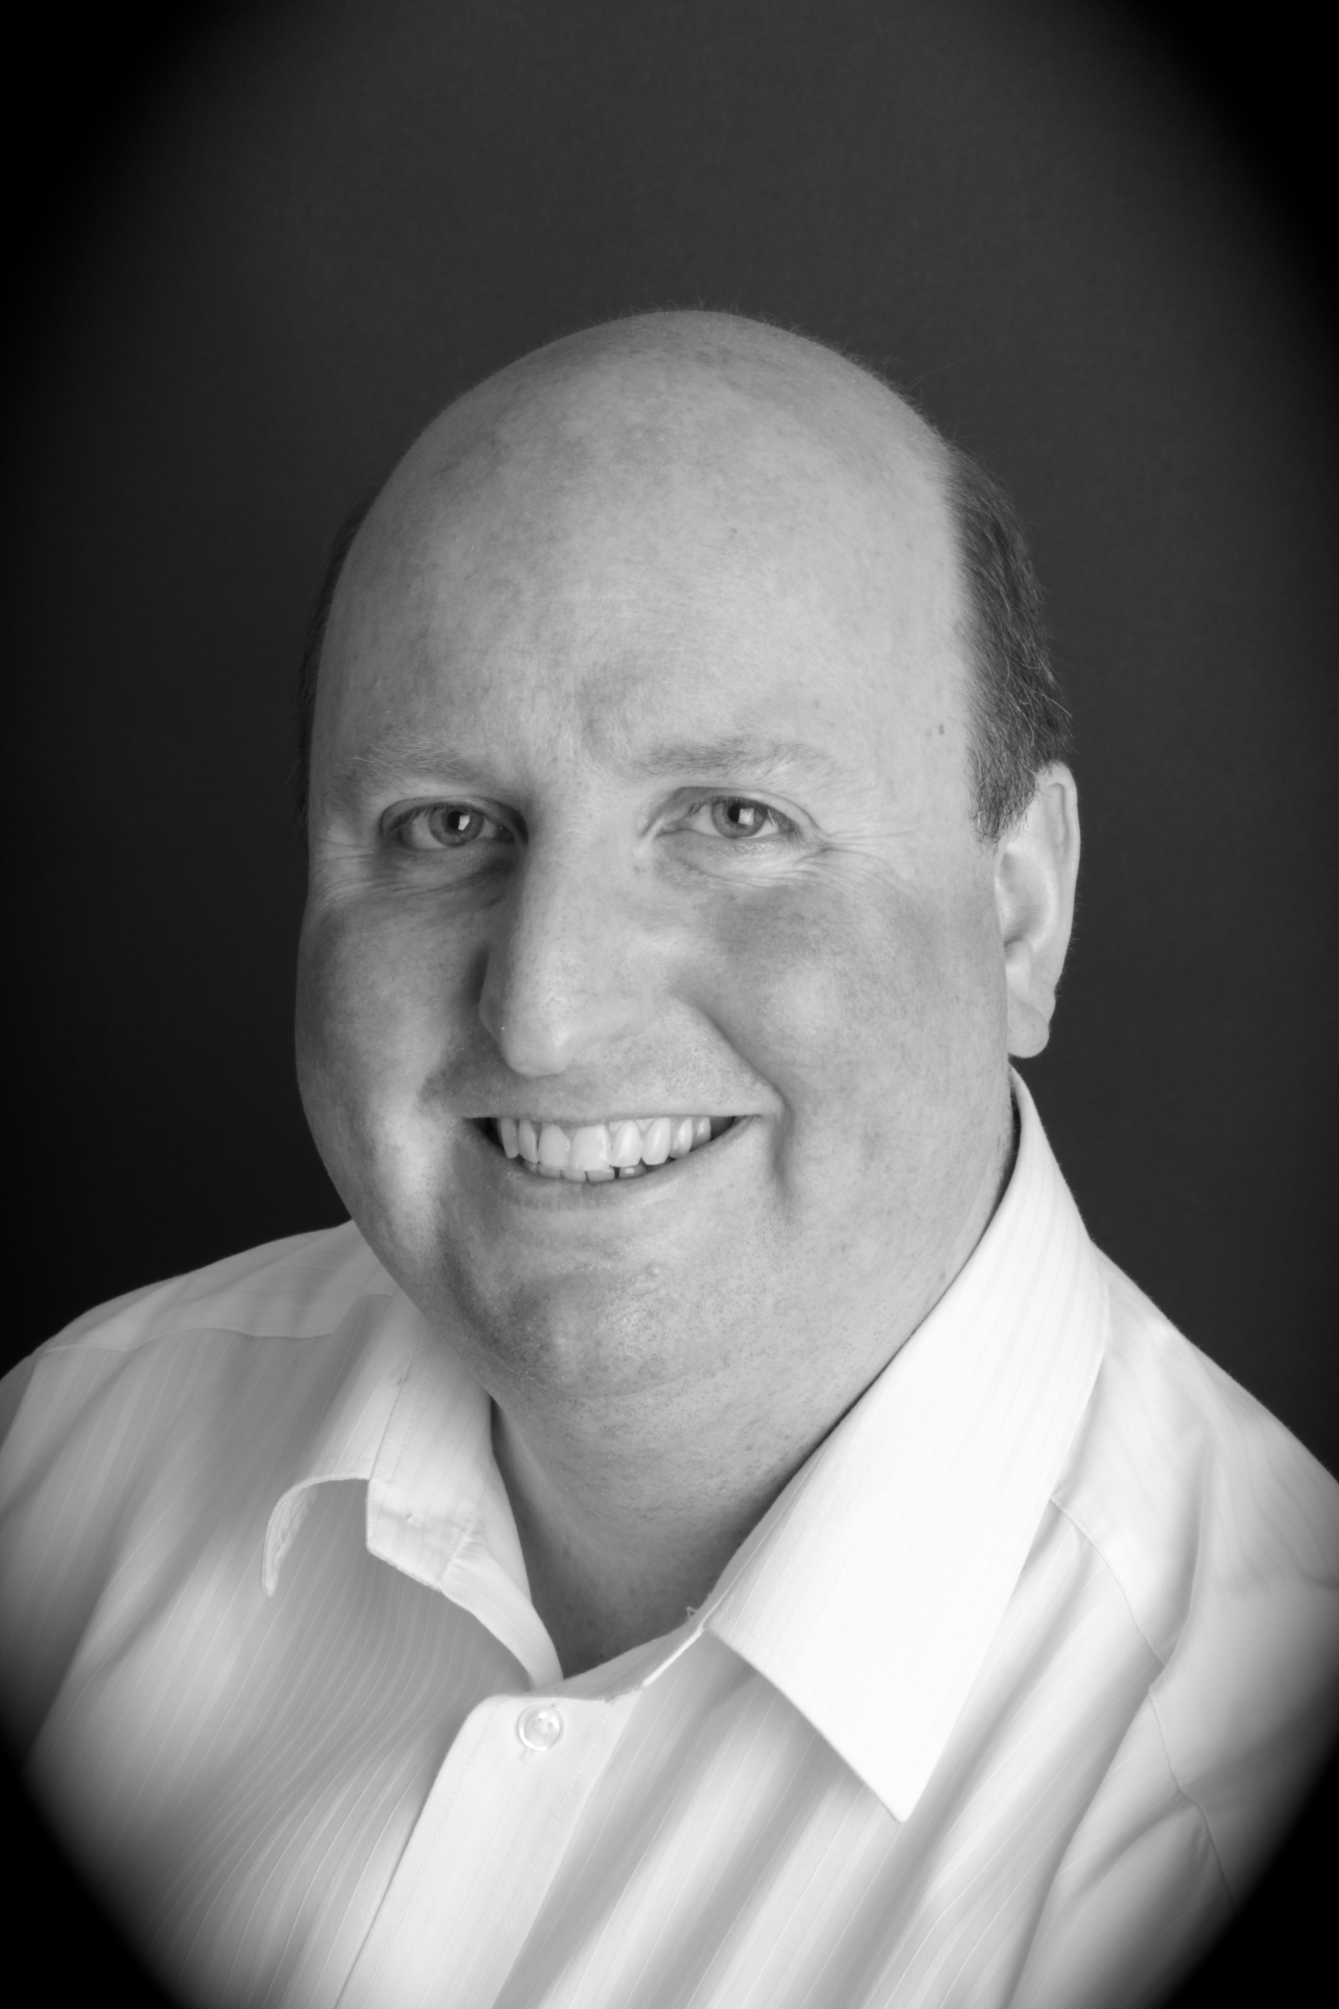

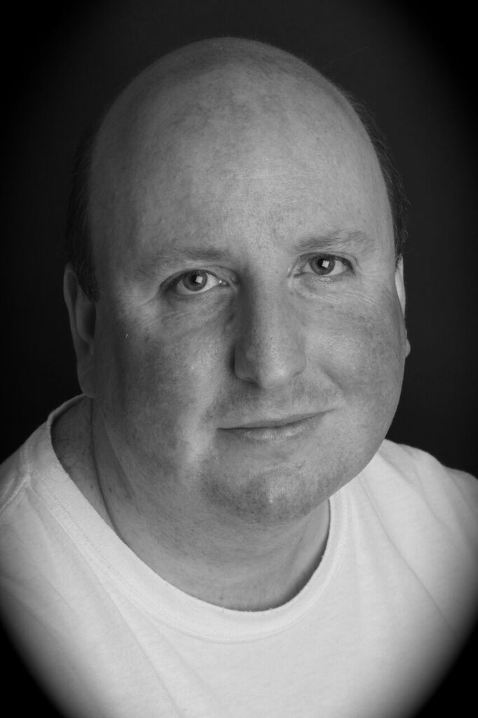

Agent’s No: 07389 134 200

Agent’s Email: [redbookcasting@outlook.com](mailto:redbookcasting@outlook.com)

Date Of Birth: 23/11/1977

#### ACTING CREDITS

YEAR / PRODUCTION ROLE COMPANY/INSTITUTION

1999 And Then There Were None (S) Doctor Armstrong DeMontfort University Leicester

1999 A Midsummer Nights Dream (S) Nick Bottom DeMontfort University Leicester

1999 In A Land Of Plenty (TV) Lead Bohemian BBC Television

1999 The King And I (S) The Kralahome West Wirral Musical Society

1999 – 2011 Trial By Jury (S) Foreman Of The Jury Lormak Productions

2001 Fiddler On The Roof (S) Perchick Rock Ferry Operatic Society

2001 A Misdummer Nights Dream (S) Francis Flute The Hillbark Players

2003 A Comedy Of Errors (S) Gailor The Hillbark Players

2005 A funny thing happened… (S) Hero Rock Ferry Operatic Society

2005 The Taming of the Shrew (S) Grumio The Hillbark Players

2006 O Jerusalem (F) Reporter & Student Canal+

2006 Treasure Island – The Musical (S) Ben Gunn Rock Ferry Operatic Society

2006 Lillies (TV) Gardener/Handyman BBC Television

2007 The Not So Great Escape (S) Captain Schmidt Livemak Productions

2007 As you like it (S) William The Hillbark Players

2008 Master to Master (S) Sir Arthur Sullivan Rock Ferry Operatic Society

2008 Pride & Prejudice- The Musical (S) Mr Wickham Lifeline Productions

2008 Waterloo Road (TV) Extra BBC Television

2009 Macbeth (S) Murderer/Seyton The Hillbark Players

2010 Oliver! (S) Mr Bumble Rock Ferry Operatic Society

2010 Crimes that shook Britain (TV) Counsel for Prosecution The History Channel

2011 Treasure Island – The Musical (S) Squire Trelawney Rock Ferry Operatic Society

2011 The Merry wives of Windsor (S) Pistol The Hillbark Players

2012 Titanic – The Musical (S) Herbert J Pitman West Kirby Light Opera

2013 “Noble” (F) Factory Worker Destiny Films

2013 Fiddler On The Roof (S) Rabbi Rock Ferry Operatic Society

2013 The Merchant of Venice (S) Launcelot Gobbo Hillbark Players

2014 Yeomen of the Guard (S) Lead Yeoman Crosby G&S Society

2014 Blackadder 2 (S) Lord Percy Carlton Players

2014 Dr Who – Dark Times (R) Cardinal Tolwyn Word of Mouth/BBC/Anglia Ruskin University

2015 The Mikado (S) Pish Tush Crosby G&S Society

2015 Blackout (F) Jack Tvplusfilms

2015 The Game’s Afoot (S) William Gillette Carlton Players

2015 Frankenstein (S) Captain Walton Carlton Players

2016 Blackout- part 2 (F) Jack Tvplusfilms

2016 Allo Allo (S) Officer Crabtree Carlton Players

2017 Love from a Stranger (S) Hodgson Carlton Players

2017 Katherine Howard (S) King Henry VIII Bebington Dramatic Society

2017 Bancroft (TV) Passer by ITV

2017 The Man in the Cave (F) John Davies TvPlus films

2017 SimpleBlood (F) The Sheriff Student Film LJM University

2017 Jeeves and Wooster (S) Seppings Carlton Players

2018 The Happiest Days of our Lives Rainbow Carlton Players

(S) = Stage (TV) = Television (F) = Film (R) =Radio

**THEATRE COMPANIES**

* Sudden Death Theatre Company (2008 – present) – specialists in murder mystery events.
* City of Chester Ghost Tours (2009 – present)

**WRITING CREDITS**

* “Anybody Home?” Stage Play - 2008 Premiere – Actors Studio, Liverpool
* “The Thing in the Hall” and “The Past and the Present” short stories for audio books – Word of mouth Productions 2014.
* “Endurance” Radio episode for an audio drama 2016.
* “Sherlock Holmes and The Curse of the Borgia Pearl” Stageplay 2016.
* “The Trial of George Martin”- Stageplay 2018

##### ADDITIONAL SKILLS

* I have a wide range of voice talents ranging from various accents/dialects to impersonations. This somewhat unique ability, has led to many radio comedy roles for a University Radio station as well as local radio and for countless comedy sketches over the years. I can perform a variety of accents including Scouse, Geordie, Birmingham, Yorkshire as well as Irish, Welsh, Scottish, French, and Pakistani. Essentially, given enough time, would be able to adapt to any voice/accent required.
* I hold a full, EU driving licence and am able to ride a bicycle.
* Can perform basic stunts such as fights and falls. Some basic Swordfighting. Can Swim and ride a horse.
* Can sing to a reasonable standard.

**AGENCY (Extra work)**

**The Casting Collectve**

Olympic House 317-321 Latimer Road London W10 6RA

Telephone: 020 8962 0099

Website: [www.castingcollective.co.uk](http://www.castingcollective.co.uk)

**TRAINING**

* 8 Week course with Banaafish Management
* 1 year course as a student with “The Actors Lab”
* Workshops with Nina Gold Casting & Joanne Moss (ITV)